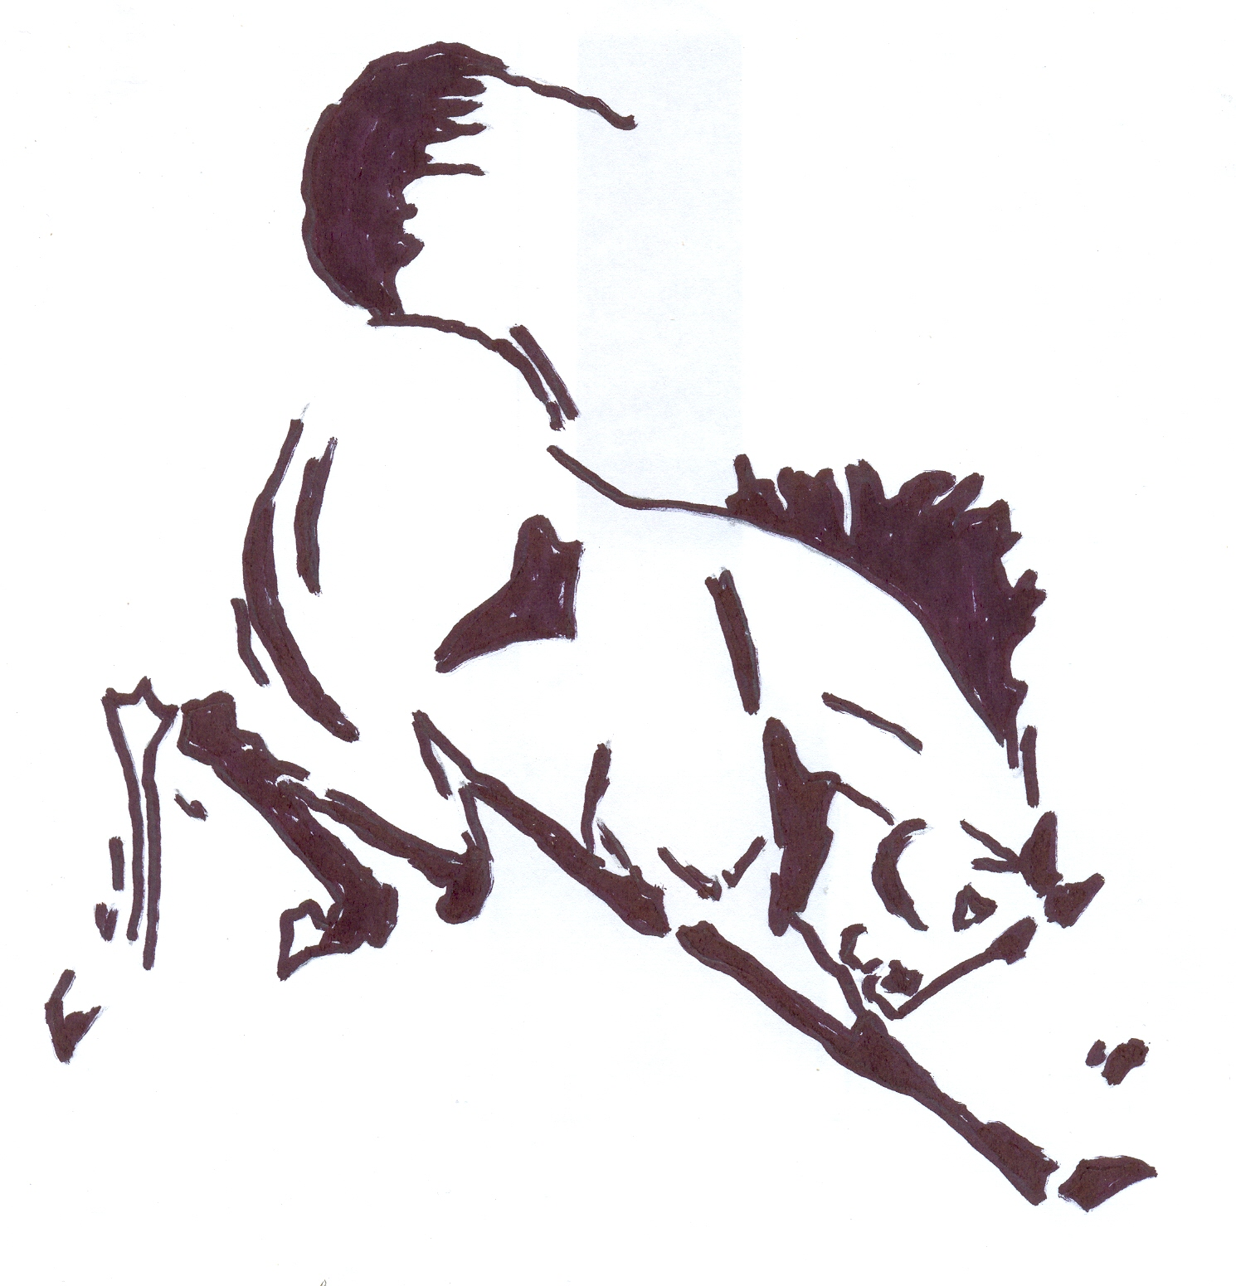
HEART TO HEART
FUNDAMENTALS OF HORSEMANSHIP
10th – 11th May 2025

9th – 10th August 2025

Two Day Rider Slot
One Day Rider Slot
Two Day Spectator Slot
One Day Spectator Slot

Please return form to:-
Ross Dhu Equestrian
Sunnyside Farm, Sunnyside Road
Quarter, Larkhall
ML9 1RB
Email: contact@scottishhorsehelp.com
Payments made via link on website.

For further information please contact:-
Morag Higgins – Tel 01698 886 492 Mob: 07979741672

Name:
Address:

Tel:

E-mail:

